**Quick Guide: CLINICAL TRIAGE GUIDELINES USING THE C‐SSRS**

Please remember that these calls are meant to be social in nature, you are not operating in a clinical capacity, however, if your older adult does talk about thoughts of death, wanting to die, euphemisms (“sad,” “feeling blue,” “lonely,” “I’m ready to go”) or anything that is concerning to you

below are some steps to guide you with an appropriate response.

Also, remember that some of these statements are normal for older adults or people who are dealing with a crisis like the pandemic, you can validate their response “It is ok for people to verbalize anxiety or depression, we would expect that”.

You can ask them more about it. Depending on what they are saying, you can or should ask them more about it. Follow your gut instinct, if it sounds off track then follow up.

Use the steps below to determine the level of risk and what your appropriate response should be.

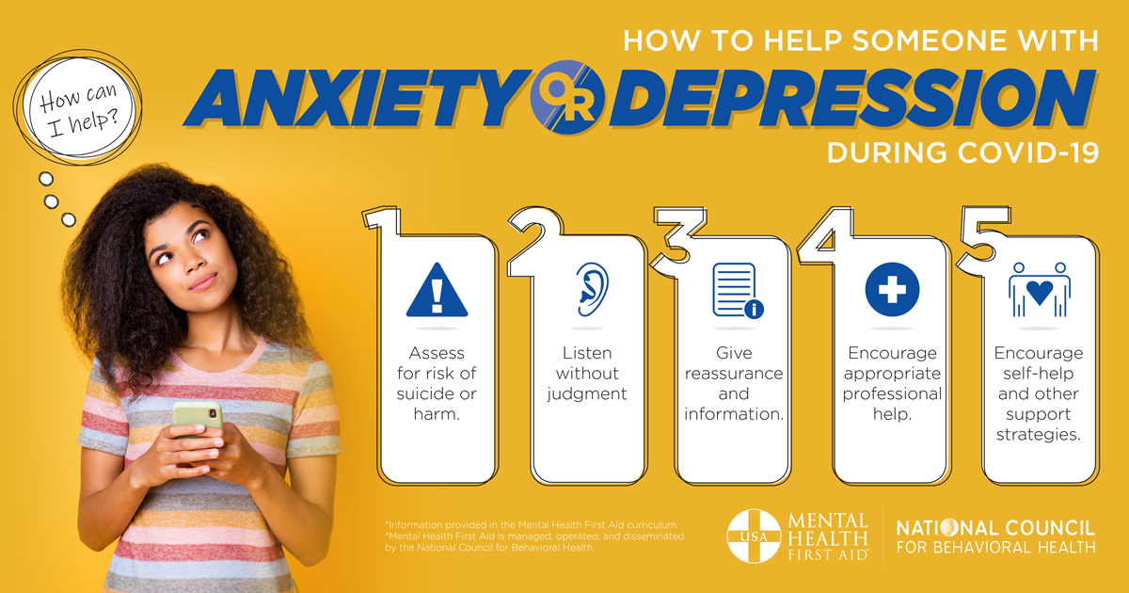

Please be familiar with the full length resources provided that include protective factors and suggested responses to address suicidal thoughts.

**Triage protocol for suicidal thoughts verbalized**

1. If detect suicidal ideations then use the CSSRS screen (below), let them know you are concerned and would like to ask some additional questions. Let them know you are a mandated reporter and are required to follow up accordingly:
   1. If low risk, then after your phone call ends call the faculty on call
      1. Use resources to engage older adult in coping skills, increasing support, and reasons to live
   2. If medium risk then call the faculty on call while your still on the phone, if faculty is not available try the next faculty on the list on call
      * 1. Safety plan:
           1. if older adult is medium risk ask questions to find out if they are seeing a mental health provider and encourage them to call them. Ask them if they are willing to provide the mental health provider’s phone number to you so you can call on their behalf
           2. ask if there is anyone around (at home, nearby) ensure they are not alone
           3. Use resources to engage older adult in coping skills, increasing support, and reasons to live
           4. Review protective factors
   3. If high risk (danger to self)
      1. ask if someone is with them, a family member, friend or caregiver, etc. and ask to talk to them. Let them know they should call 911 because the older adult is in immediate danger to self
      2. if the older adult is alone and high risk, has ideations, intent, plan and means an urgent intervention is required, call 911 then also let them know that you care about their well-being and will be sending someone to look in on them, and that “they are coming to help you”. Obtain their address, use your conference calling option on your phone, keep your older adult on the phone when you call 911.
      3. After the situation has resolved immediately contact the faculty member on call

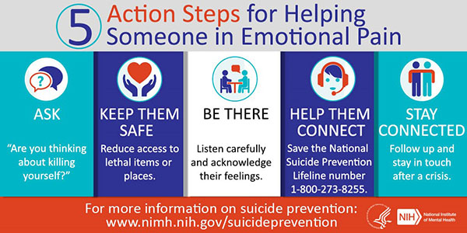

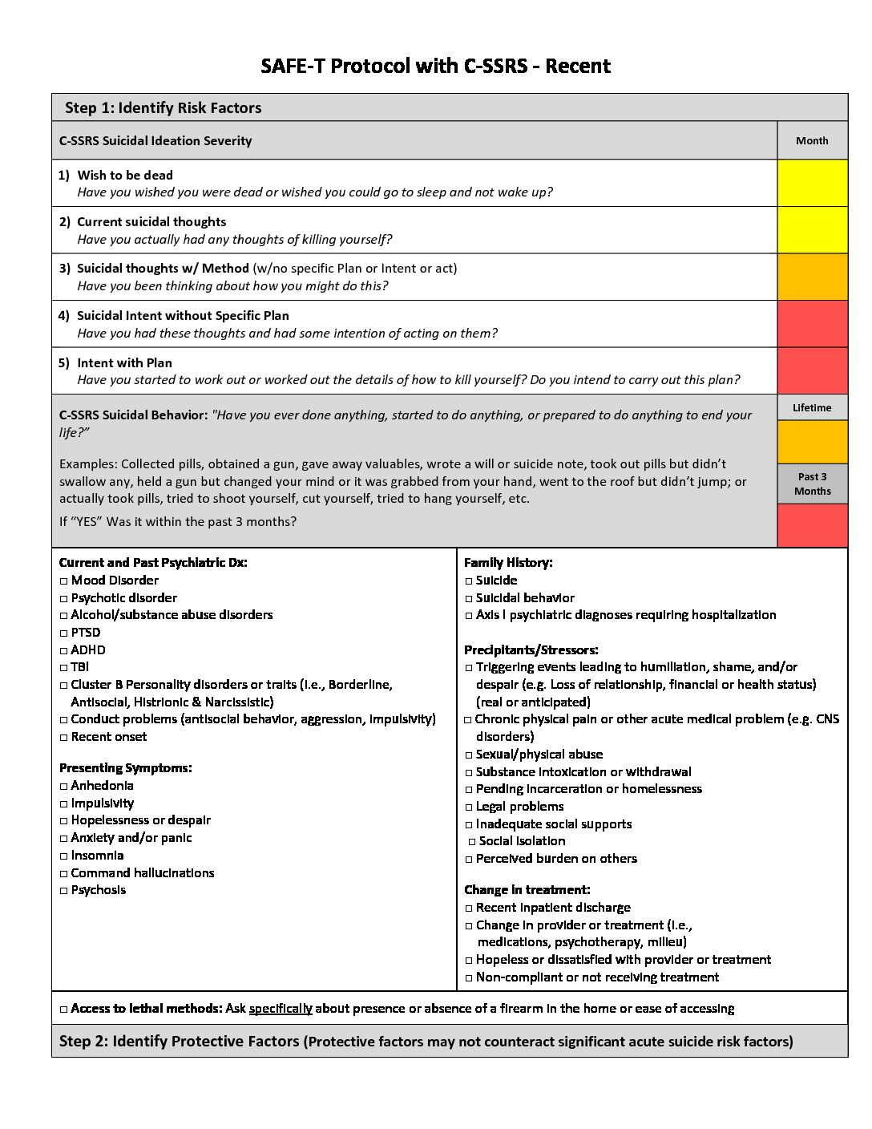



Suicide Prevention Line

**The 988 Lifeline**

988 is now active across the United States. This new, shorter phone number will make it easier for people to remember and access mental health crisis services. (Please note, the previous 1-800-273-TALK (8255) number will continue to function indefinitely.)